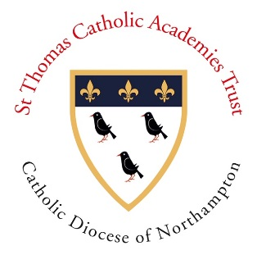

**St. Ethelbert’s Catholic**

**Primary School and Nursery**

***‘Learning, achieving and growing together with Jesus’***

**Headteacher: Mrs F.Maynard**

Wexham Road, Slough, Berkshire SL2 5QR

Telephone: 01753 522048 Fax: 01753 552613

“The glory of God is a human being fully alive!”

[post@stethelberts.slough.sch.uk](mailto:post@stethelberts.slough.sch.uk)

Tuesday 03rd November

**School Remains Open**

Dear Parents and Carers,

We have had some enquiries about what will happen with school from Thursday 5th November when England will go into a ‘lockdown’ for 4 weeks. **School remains open for all pupils.**

The Prime Minister has made it clear that the benefits of being at school for children in terms of education and wellbeing are of paramount importance. I understand that there will be some anxiety in parents but would like to assure you that the Government guidelines are being followed in school and I am committed to keeping your children and my staff safe.

The children are happy and settled, and have adapted to the new routines since September. We will continue to focus on their learning and emotional wellbeing as we work with them in this second half term.

*If your child is unwell, please do not send them to school. If you or anyone in your household displays symptoms of coronavirus, please follow the official guidelines carefully and isolate as directed.*

I would like to thank all parents for their continued understanding and support.

God Bless,

Fiona Maynard

Headteacher